# Research Report - sources of financial crime data

**Contributors:** [sabdullahi@deakin.edu.au](mailto:sabdullahi@deakin.edu.au); [s222147704@deakin.edu.au](mailto:s222147704@deakin.edu.au); [dnunes@deakin.edu.au](mailto:dnunes@deakin.edu.au)

## Introduction:

Financial crime, encompassing a wide spectrum of illicit activities aimed at gaining illegitimate financial benefits, poses a significant threat to the global economy and financial systems. To effectively combat this pervasive issue, researchers and policymakers need access to reliable and comprehensive financial crime data. This report delves into the diverse sources of financial crime data, exploring their strengths, limitations, and utilisation strategies.

### The primary sources of financial crime data include:

**Transaction Data:** A vast repository of financial records, encompassing bank transfers, credit card transactions, and online payments, providing insights into spending patterns, fund movements, and potential anomalies indicative of fraud.

**Customer Data:** Comprising demographic information, employment details, and transaction history, customer data aids in identifying potential risks and suspicious activities, enabling targeted fraud prevention measures.

**Third-Party Data:** External sources, such as public records, social media, and credit reports, supplement traditional customer data, providing additional insights into individuals' financial behaviors and potential risk factors.

**Regulatory Data:** Financial intelligence reports (FINTRs) and regulatory filings offer valuable insights into the nature and scope of financial crime, enabling the assessment of existing prevention measures.

**Law Enforcement Data:** Law enforcement records, including crime reports and investigative details, provide insights into criminal methodologies, modus operandi, and emerging threats.

**Whistleblower reports:** Whistleblowers are individuals who report suspected financial crimes to the authorities. Whistleblower reports can be a valuable source of information, as they often come from people who have firsthand knowledge of the wrongdoing.

**News articles and media reports:** Journalists often play an important role in exposing financial crimes. They can do this by investigating suspicious activity, interviewing whistleblowers, and analyzing public records.

## What is Financial Crime?

Financial crime is commonly characterised as offenses against property, encompassing the illicit appropriation of property owned by others for one’s personal use and gain. (Gottschalk, 2010). Financial crime, ranging from fraud such as identity theft to large-scale operations like money laundering—estimated at around $2 trillion annually by the UNODC—disproportionately affects vulnerable populations, underscoring the urgency for implementing privacy-preserving technologies to counteract these crimes. Financial institutions combat financial crime by monitoring transactions, and adhering to AML rules, but they are constrained by privacy concerns, data breach risks, and stringent regulatory compliance, hindering the free exchange of information. Data-sharing can enhance the detection of crimes and predictive analytics to prevent financial crimes. The most effective fight against financial crime requires the collaboration of financial institutions and public authorities.

As stated by (Gottschalk, 2010) **financial crime categories** consist of:

**1.** **Corruption**

**2.** **Fraud**

**3.** **Theft**

**4.** **Manipulation**

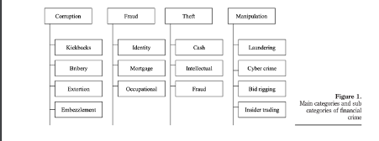

Source: (Gottschalk, 2010)

Financial crime in Australia encompasses a wide range of illegal activities that aim to gain financial benefit through illegitimate means. These activities can be broadly categorized into three main types:

**Fraud:** Fraud involves deceiving or tricking someone into surrendering money or property. Examples of fraud in Australia include accounting fraud, financial planning misconduct, and cartel conduct.

**Money laundering:** Money laundering is the process of disguising the proceeds of crime to make them appear legitimate. This often involves moving illicit funds through complex financial transactions to conceal their origins. Examples of money laundering in Australia include the Tabcorp, Westpac, CBA, ANZ, and NAB scandals.

**Cartel and organized crime:** Cartels are groups of businesses that collude to manipulate markets, reduce competition, and fix prices. Organized crime groups engage in a range of criminal activities, including financial fraud, money laundering, and drug trafficking.

## What Data sources are available?

There is exponential growth in financial crimes around the world. Criminal organisations and individuals are using more sophisticated techniques to evade detection. Financial institutions and governments are using sophisticated machine learning techniques to fight financial crime. The fight against financial crime needs voluminous and high-quality data. **More quality data enhances model performance.**

Complex models require not only internal data sources but also external data sources. Data sources for financial crime in Australia can come from various sources, and government agencies, regulatory bodies, financial institutions, and law enforcement. These agencies are important in collecting and analysing financial crime data.

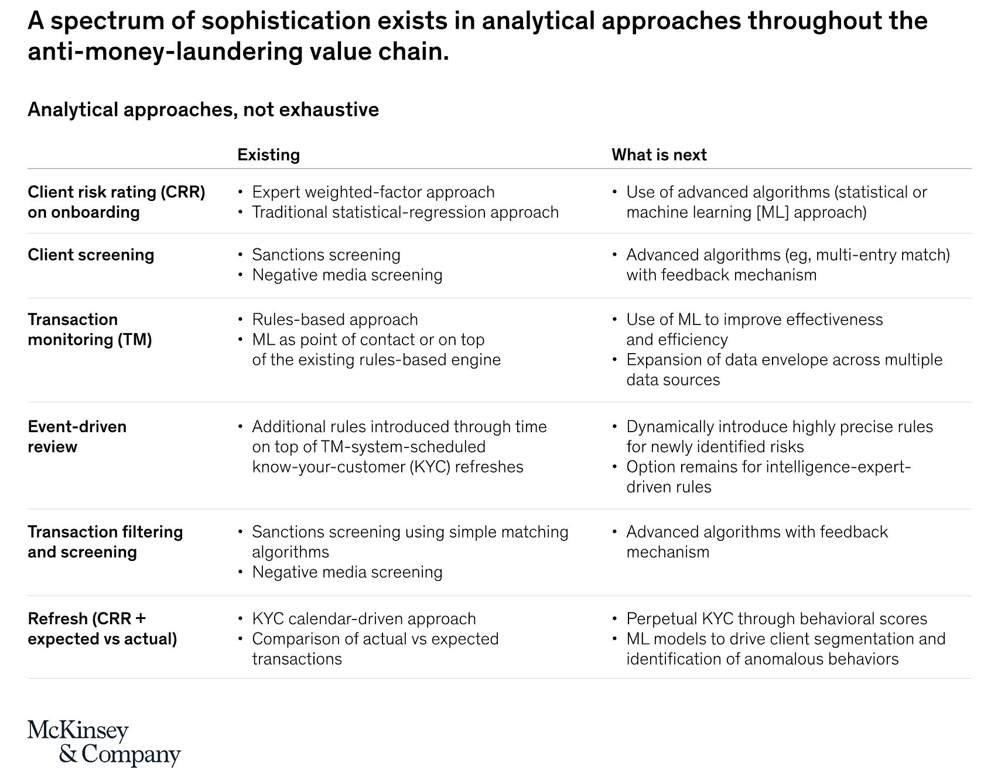

Source: Doppalapudi PK., Kumar, P., Murphy, A., Werner, S., Zhang, S., Rougeaux, C., and Stearns, R. (n.d.)

A variety of data sources can be utilised to study and develop prevention techniques for detecting financial crime. These sources provide valuable insights into criminal patterns and behaviors’, enabling the development of effective risk assessment models and fraud detection systems.

**Transaction Data:** Bank transfers, credit card transactions, and online payments.

**Customer Data:** Demographics, employment details, and transaction history.

**Third-Party Data:** Public records, social media, and credit reports.

**Regulatory Data:** Financial crime reports and regulatory filings.

**Law Enforcement Data:** Crime reports and investigative records.

**Data sources and agencies for financial crime in Australia:**

· Australian Transaction Reports and Analysis Centre (AUSTRAC)

· Australian Securities and Investments Commission (ASIC)

· Australian Prudential Regulation Authority (APRA)

· Australian Competition and Consumer Commission (ACCC)

· Australian Federal Police (AFP)

**Data sources for the project:**

|  |  |
| --- | --- |
| **Kaggle** | [**https://www.kaggle.com/**](https://www.kaggle.com/) |
| **Australia Bureau of Statistics** | [**https://www.abs.gov.au/**](https://www.abs.gov.au/) |
| **Australian Banking Association** | [**https://www.ausbanking.org.au/data-research/data/**](https://www.ausbanking.org.au/data-research/data/) |
| **Data.gov.au** | [**https://data.gov.au/home**](https://data.gov.au/home) |
| **Research Data Australia** | [**https://researchdata.edu.au/**](https://researchdata.edu.au/) |
| **UN data** | [**https://data.un.org/**](https://data.un.org/) |
| **World Bank data** | [**https://data.worldbank.org/**](https://data.worldbank.org/) |
| **FinCEN data** | **https://www.icij.org/investigations/fincen-files/download-fincen-files-transaction-data/** |

### Sources of data about financial crime in Australia:

**AUSTRAC** Financial Intelligence Reports: AUSTRAC, the Australian Transaction Reports and Analysis Centre, is a government agency responsible for combating financial crime in Australia. AUSTRAC collects financial intelligence reports (FINTRs) from financial institutions and other reporting entities, which contain information about suspicious transactions and activities. These FINTRs provide valuable insights into the nature and scope of financial crime in Australia.

**Australian Prudential Regulation Authority** (APRA) Data: APRA, the prudential regulator for the Australian financial system, collects a wide range of data from financial institutions, including data on fraud losses, cybercrime incidents, and anti-money laundering (AML) activities. This data provides valuable insights into the risks of financial crime faced by Australian financial institutions and the effectiveness of their AML controls.

**Australian Bureau of Statistics** (ABS) Data: The ABS, Australia's national statistical agency, collects data on a range of topics, including crime and justice. The ABS's Crime Victimisation Survey provides data on the prevalence of financial fraud among Australian households and businesses. This data can be used to track trends in financial crime over time and identify areas where prevention efforts are needed.

**Australian Federal Police** (AFP) Data: The AFP, Australia's national police force, collects data on a range of crimes, including financial crime. The AFP's Financial Crime Data Repository contains information about financial crime investigations and prosecutions. This data can be used to identify emerging trends in financial crime and develop targeted prevention strategies.

**Academic Research:** Researchers at universities and other research institutions conduct studies on financial crime in Australia. These studies often use data from a variety of sources, including AUSTRAC FINTRs, APRA data, ABS data, and AFP data. Academic research can provide valuable insights into the causes and consequences of financial crime and inform the development of effective prevention strategies.

## What Datasets are available?

There are a plethora of datasets for financial crime analysis and research from a vast amount of sources. The chosen dataset depends on the different categories of financial crimes. However, due to privacy concerns and regulations the availability of dataset is limited.

We have collected four financial datasets from Kaggle which consist of three synthetic datasets and one real anonymised dataset.

1. **Synthetic Financial Dataset for Fraud Detection**: Synthetic datasets generated by the PaySim mobile money simulator.
2. **Synthetic Fraudulent Transaction Detection**: Financial transaction labeled as fraudulent or legitimate.
3. **Synthetic IBM Transactions for Anti Money Laundering (AML)**
4. **Credit Card Fraud Detection Dataset 2023:** Real anonymised dataset

# **FinCEN Files transaction data:** financial intelligence reports that reveals the role of global banks in industrial-scale money laundering

### Why did we use the Synthetic Dataset to study financial crime?

As sourcing actual customer data was not possible for this piece of work, our team used a few sources of synthetic dataset. The advantages were.

**Data Privacy:** Synthetic data eliminates the privacy concerns associated with real financial crime data, which often contains sensitive customer information. This allows researchers to safely analyses and study financial crime patterns without compromising individual privacy.

**Data Availability:** Real financial crime data is often limited and not readily available for research purposes due to privacy restrictions and data ownership issues. Synthetic data can be generated in large quantities, providing researchers with the data volume they need to conduct comprehensive studies.

**Data Control:** Synthetic data generation allows researchers to control the data distribution and characteristics, enabling them to create specific scenarios and test different hypotheses without relying on limited real-world data.

**Reproducibility:** Synthetic data can be easily reproduced and shared among researchers, facilitating collaboration and consistency in research findings.

**Machine Learning Applications:** Synthetic data is well-suited for training and evaluating machine learning models used in fraud detection and financial crime prevention. It can be used to create diverse and realistic training datasets without exposing sensitive customer information.

## What was the EDA that was done?

## Explanation for each privacy-preserving technique dose as part of EDA:

## **Differential Privacy**

## We have used the synthetic datasets and written code to apply privacy preserving techniques. The code demonstrates the application of differential privacy (DP) to protect the privacy of sensitive data, specifically deposit amounts in this case. It involves adding controlled noise to the data to make it difficult for an attacker to re-identify individual transactions while still preserving the overall statistical properties of the data.

## **Federated Learning**

## Similarly, The code was applied to the synthetic dataset to illustrates the concept of federated learning, a distributed machine learning approach where multiple parties collaboratively train a model without sharing their individual data.

## **Homomorphic Encryption**

## Again, the code was applied to the Synthetic dataset to demonstrates the basic operations of homomorphic encryption, a technique that allows performing computations on encrypted data without decrypting it.

## **Secure Multiparty Computation (SMC)**

## The code was again applied to the synthetic dataset which implements Shamir's Secret Sharing, a technique for secure multiparty.

**Bank Transaction Data**

Code to start analysis on this or similar dataset. This code reads an excel file named 'bank.xlsx' and filters the data to keep only rows where the deposit amount is greater than 8000 and less than 10,000. It then saves the filtered data to a new CSV file named '001.csv'.

This code can be used to study financial crime detection by identifying potential suspicious activity based on transaction amounts. By filtering the data to include only transactions where the deposit amount is between 8,000 and 10,000, the code can identify transactions that are outside of the normal range for most account holders. This type of activity could be indicative of money laundering or other financial crimes.

**Here are some specific ways in which this code could be used to study financial crime detection:**

**Identifying potential money laundering:** Money launderers often use large cash deposits to try to hide the source of their illicit funds. By identifying transactions where the deposit amount is between 8,000 and 10,000, the code can flag these transactions for further investigation.

**Identifying potential fraud:** Fraudsters may also use large deposits to try to scam victims. By identifying transactions where the deposit amount is between 8,000 and 10,000, the code can flag these transactions for further investigation.

**Understanding patterns of suspicious activity:** By analyzing the data from the filtered transactions, researchers can identify patterns of suspicious activity. This information can then be used to develop new and more effective methods of detecting financial crimes.

## What are the hurdles in obtaining financial crime data?

Many financial crimes go underreported, businesses may hesitate to report financial crime too concerned to lose reputation or public trust. Public authorities and private entities find compiling comprehensive meaningful datasets challenging. The main reason that a comprehensive dataset on financial crime is difficult to acquire is privacy concerns and regulatory constraints. The second main reason is data fragmentation. This means data is fragmented across many institutions. The fight against financial crime would greatly benefit from collaboration on data sharing among these institutions.

Furthermore, obtaining financial crime data for research and analysis can be challenging due to several hurdles, including:

**Data Availability and Accessibility:** Financial institutions and law enforcement agencies often have strict data privacy and confidentiality policies that restrict access to financial crime data. This can make it difficult for researchers to obtain the data they need to conduct meaningful studies.

**Data Quality and Consistency:** The quality and consistency of financial crime data can vary depending on the source and the methods used to collect and store the data. This can make it difficult for researchers to generalize their findings and draw accurate conclusions.

**Data Integration and Harmonization:** Financial crime data can be siloed across different institutions and agencies, making it difficult to integrate and harmonize the data for comprehensive analysis. This can hinder efforts to identify patterns and trends across different types of financial crime.

**Data Sensitivity and Confidentiality:** Financial crime data often contains sensitive and confidential information, such as customer financial records and investigative details. This raises concerns about data privacy and the potential for misuse of the data.

## What are the solutions for it?

Creating synthetic datasets for financial crime when real datasets are unavailable due to privacy concerns and regulations can be a viable solution. However, it’s crucial to note that the effectiveness of synthetic datasets depends on the quality of the generation process. The synthetic data should accurately capture statistical properties and patterns present in real financial data to ensure that models trained on such data are relevant and reliable in real-world applications.

### Potential solutions to address these challenges:

**Establish Clear Data Sharing Guidelines and Protocols:** Develop clear and consistent guidelines and protocols for data sharing between financial institutions, law enforcement agencies, and research institutions. These guidelines should outline data access procedures, data use restrictions, data privacy and confidentiality measures, and mechanisms for dispute resolution.

**Promote Data De-identification and Anonymization:** Encourage the use of data de-identification and anonymization techniques to protect the privacy of individuals while preserving the utility of the data for research and analysis. De-identification involves removing or modifying personally identifiable information, while anonymization involves transforming data to render it statistically unidentifiable.

**Invest in Data Infrastructure and Expertise:** Allocate resources to develop and maintain robust data infrastructure that can securely store, manage, and process large volumes of financial crime data. Invest in training and development programs to enhance the data management and analysis expertise of researchers and data analysts working with financial crime data.

## Elaborate on any coding used for this report?

**Differential Privacy:**

The code that was written used Differential privacy which is a technique for releasing statistical information about a dataset while protecting the privacy of individuals in the dataset. It works by adding noise to the data in a way that makes it difficult for an attacker to re-identify any individual in the dataset, even if they have access to the noisy data. The amount of noise added to the data is a trade-off between privacy and accuracy. More noise means greater privacy protection, but it can also make it harder to get accurate results from the data.

**Federated Learning:**

The code that was written used Federated learning which is a technique for training machine learning models on private data without sharing the data itself. It works by having each party train a local machine learning model on their own data and then sending the model parameters to a central server. The central server aggregates the model parameters and updates the global machine learning model. This process is repeated multiple times until the global machine learning model has learned from all of the local data without any of the data ever leaving the local devices or servers.

**Homomorphic Encryption:**

The code uses Homomorphic encryption which is a technique for performing computations on encrypted data without decrypting it first. This means that you can perform computations on sensitive data without ever exposing the data itself to the untrusted environment where the computations are being performed. Homomorphic encryption is based on the idea that you can encrypt a computation and then decrypt the result. The result will be the same as if you had performed the computation on the unencrypted data.

## Where are the code stores?

All code saved and stored here:

<https://github.com/DataBytes-Organisation/Privacy-Technologies-for-Financial-Intelligence>

## Conclusion and Summary

The report concludes that synthetic datasets and privacy-preserving techniques offer promising solutions for addressing the challenges of obtaining and analysing financial crime data. By using these techniques, researchers and policymakers can gain valuable insights into financial crime patterns and develop more effective detection and prevention methods.

## Reference

Gottschalk, P. (2010), *Categories of financial crime*, Journal of Financial Crime*,* Vol. 17 No.4, pp. 441

458.

Doppalapudi PK., Kumar, P., Murphy, A., Werner, S., Zhang, S., Rougeaux, C., and Stearns, R. (n.d.)

Risk & Resilience. [blog] *Machine learning is the future for anti-money laundering.* Available at:

[https://www.mckinsey.com/capabilities/risk-and-resilience/our-insights/the-fight-against-money-](https://www.mckinsey.com/capabilities/risk-and-resilience/our-insights/the-fight-against-money-laundering-machine-learning-is-a-game-changer) laundering-machine-learning-is-a-game-changer

United Nations: Office on Drugs and Crime (n.d) *Money Laundering,* accessed November 2023,

[https://www.unodc.org/unodc/en/money-laundering/overview.html#:~:text=The%20estimated%](https://www.unodc.org/unodc/en/money-laundering/overview.html#:~:text=The%20estimated%20amount%20of%20money,Terrorist%20Financing)

[20amount%20of%20money,Terrorist%20Financing](https://www.unodc.org/unodc/en/money-laundering/overview.html#:~:text=The%20estimated%20amount%20of%20money,Terrorist%20Financing)